Unit 6 I'm watching TV.
Ⅰ.写出下列动词的-ing形式
do____________ watch____________ clean____________
eat____________ read____________ write____________
talk____________ play____________ shop____________
get____________ swim____________
Ⅱ.看图回答下面的问题
What are you doing?
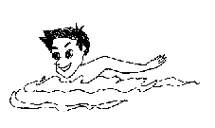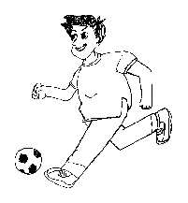
I ____________ I ____________
What's she doing?
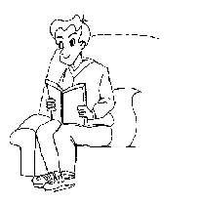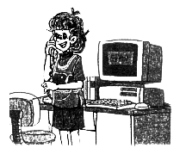
I ____________ She _______________
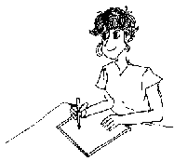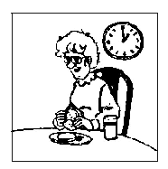
She _________ She _________
What are they doing?
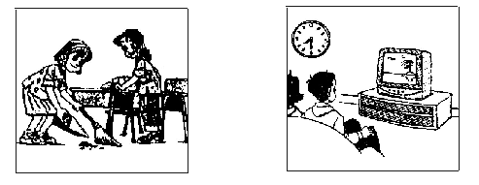
They _________ They __________
Ⅲ.将下列句子改否定句和一般疑问句
1.We are watching TV.
2.The boy is running.
3.The old man is cleaning the room.
4.I'm reading.
参考答案
Unit 6 I'm watching TV.
Ⅰ.doing, watching, cleaning, eating,reading,writing, talking,playing, shopping,getting, swimming
Ⅱ.am swimming;am playing football;am reading;is telephoning;doing her homework;is eating;are cleaning the room;are watching TV
Ⅲ.1.We aren't watching TV.Are you watching TV?
2.The boy isn't running.Is the boy running?
3.The old man isn't cleaning the room.Is the old man cleaning the room?
4.I'm not reading.Are you reading?

